Team Meeting Minutes
Meeting Details
Date: 26/05/2026
Time: 10:00 am
Location/Platform: CU London University, S109/ In-person Meeting
Chair: Sabina Mahat
Minute-Taker: Sabina
Attendees: 5
Agenda Items
1. Discuss about the Assignment
2. Finalize the game
3. Features of Game
4. Divide the responsibility
Decisions Made Decided to change the game idea and finalize with creating “Car Rush”. The responsibility for each member was assigned with the addition of deadline.
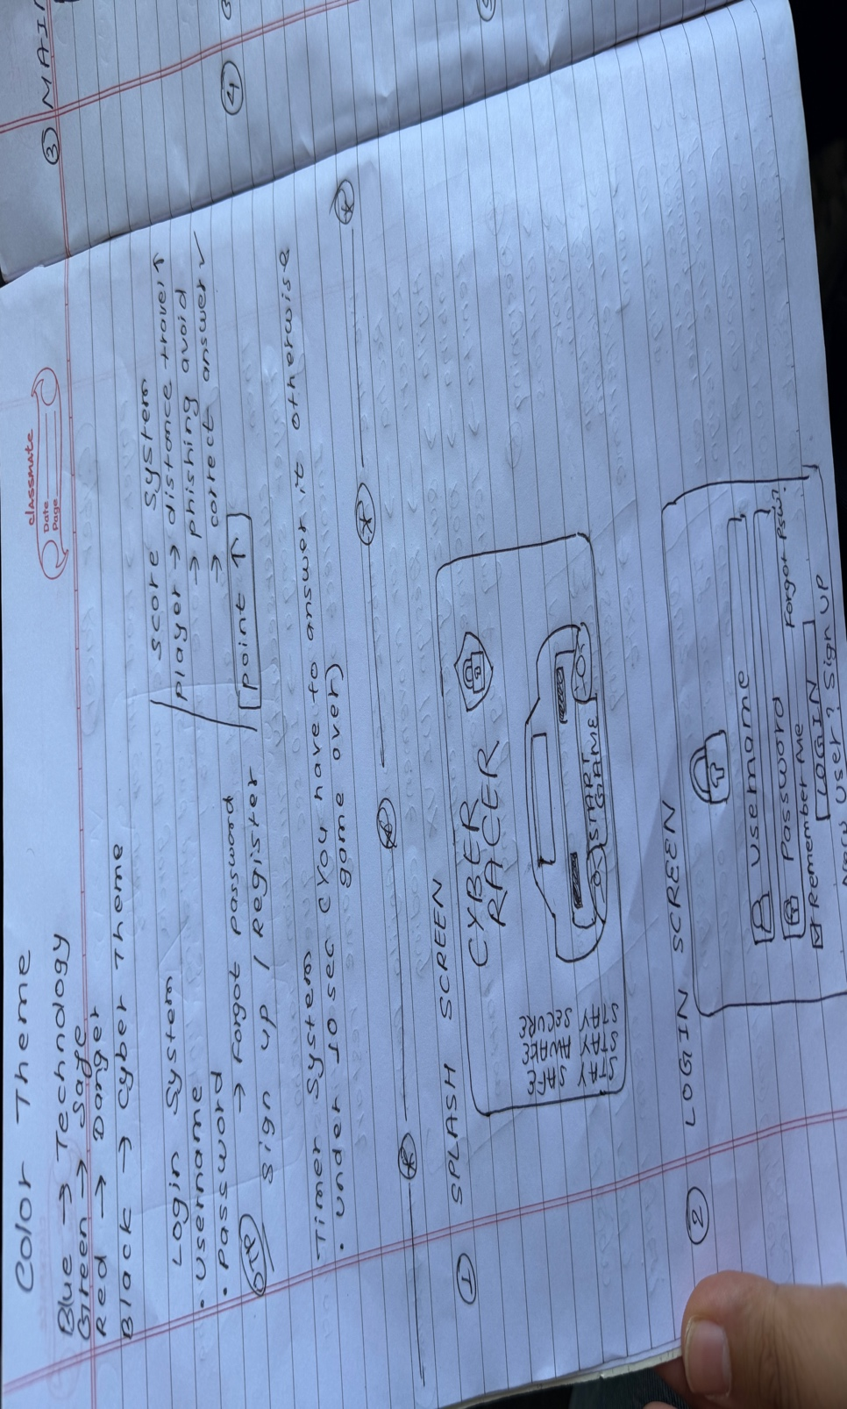

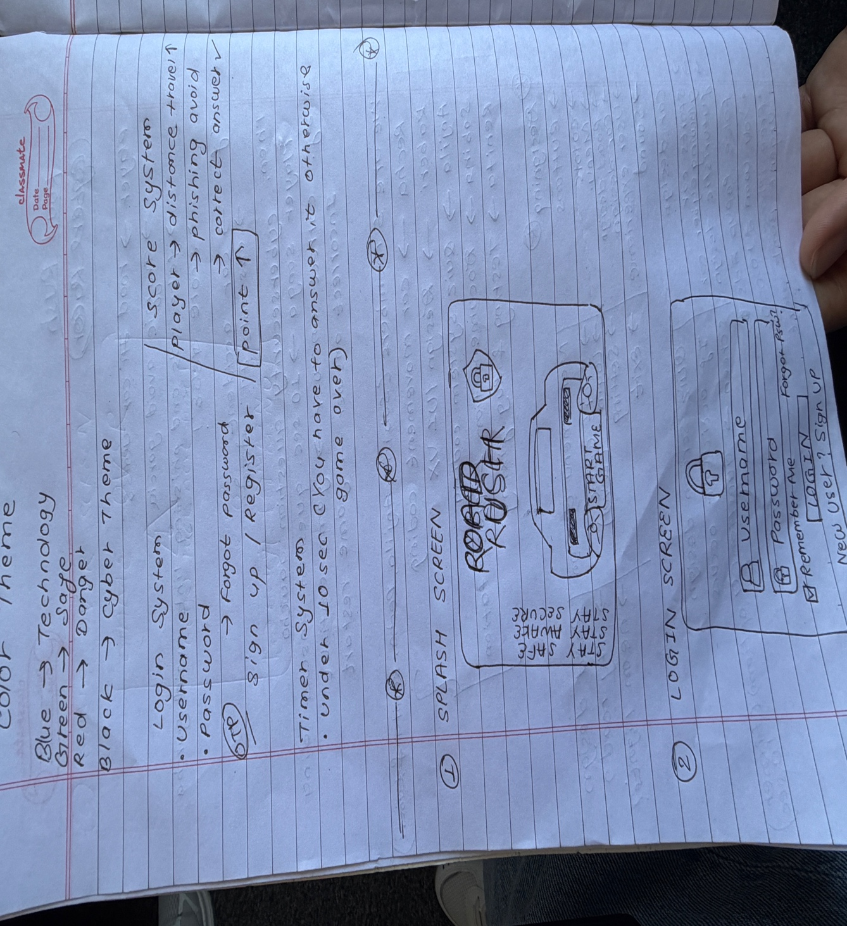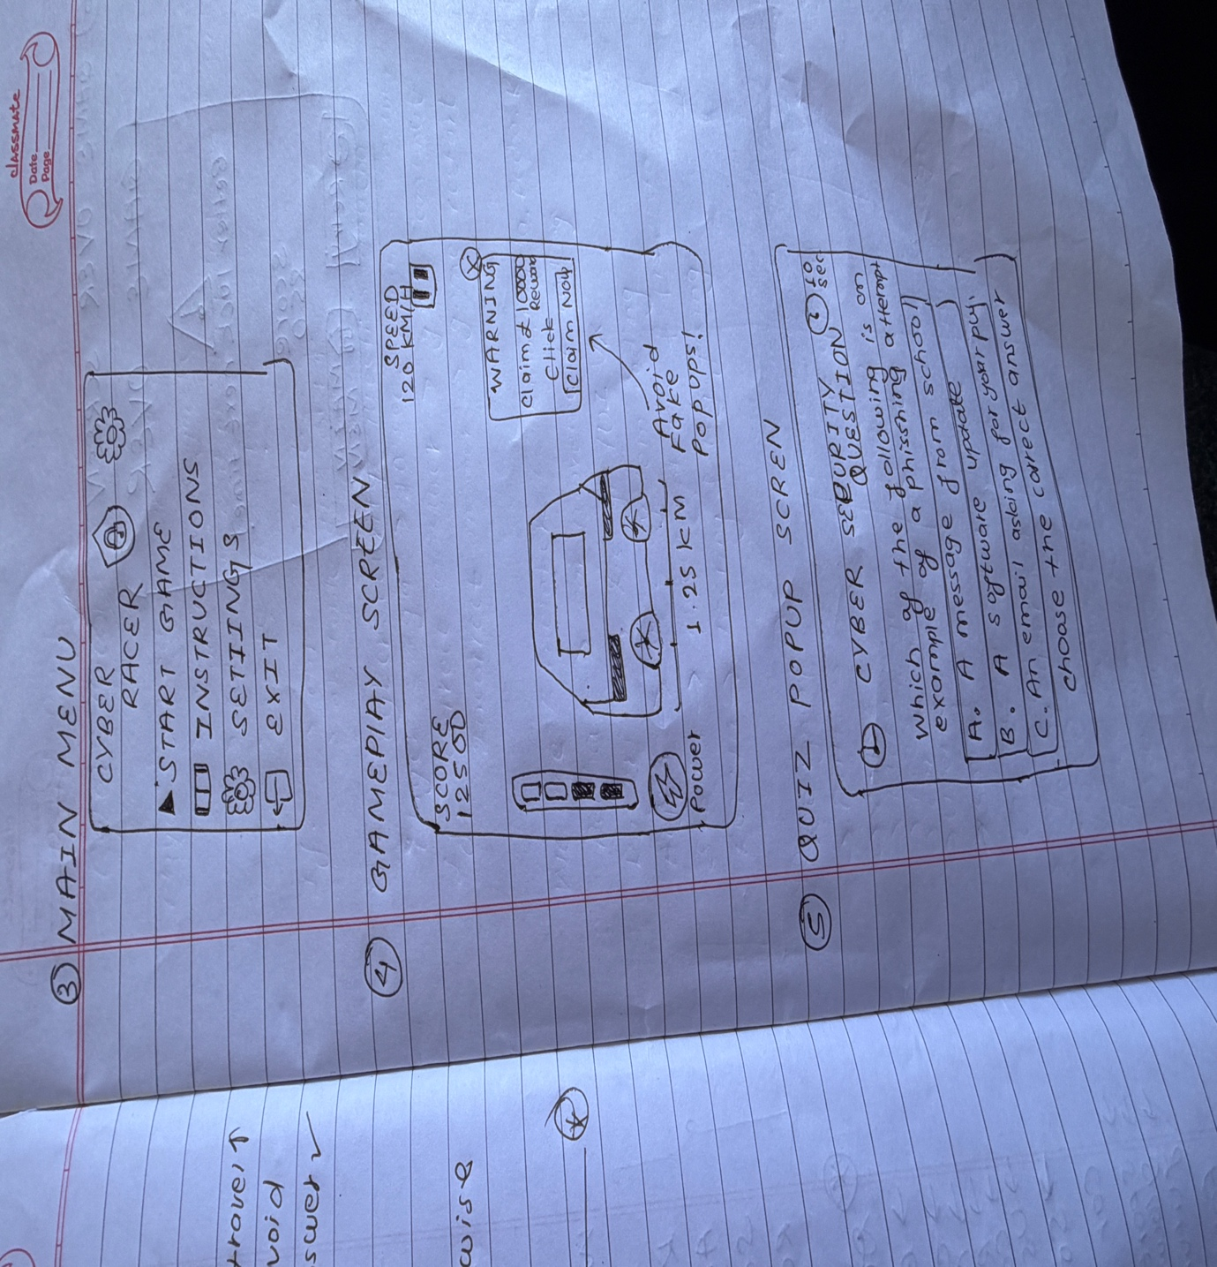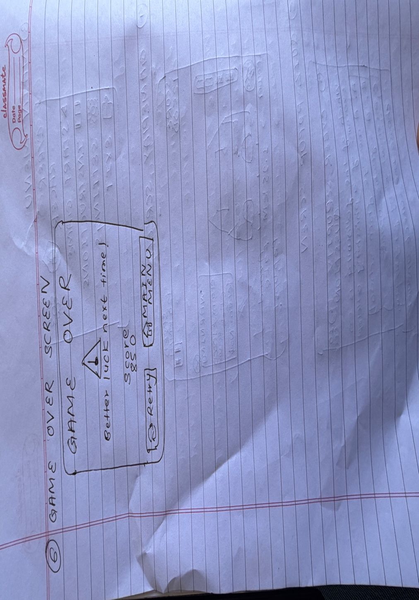
__________________________________________________________________
Action Items
Task/Action | Responsible Person | Deadline
Planning | Renita, Sabina | 26/05/2026
Base layout | Everyone | 26/05/2026
Programming | Richa | 27/05/2026
Designing | Kaberi | 29/05/2026
Testing | Anjila, Sabina | 31/05/2026
Research | Anjila, Sabina | 27/05/2026

Next Steps / Next Meeting
Feedback/ 01/06/2026
Improvisation/ 02/06/2026

